

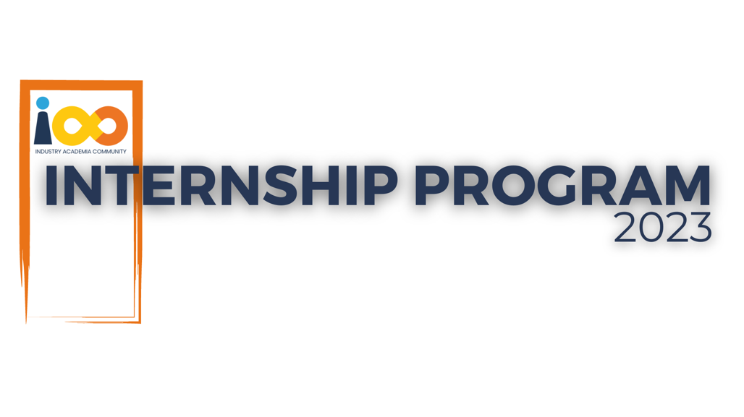

PROJECT REPORT

Data Analytics  
  
Student Interns Analysis

|  |  |  |  |
| --- | --- | --- | --- |
| **Created By:** | Tammineni Ganesh | **Approved By:** | Suraj Mane |
| **Created On:** | 29-05-2024 | **Approved On:** |  |

Page left blank intentionally

**INDEX**

**1** **PROJECT DETAILS** 2

**2** **SUMMARY** 2

**3** **INTRODUCTION** 2

3.1 Background 2

3.2 Stakeholders 2

3.3 Objectives 2

**4** **METHODOLOGY** 3

4.1 Considerations & Assumption 3

4.2 Approach 3

4.3 Activities 3

**5** **TARGETTED V/S ACHIEVED OUTPUT** 4

**6** **CONCLUSION** 5

**7** **APPENDICES** 7

7.1 Appendix A – Title 7

**General Instructions for using the Live Project Report Template**

* This template and the subsequent document created using this template is a confidential document and is the intellectual property of Cloud Counselage Pvt. Ltd. Circulating it outside of the organisation without the consent of Cloud Counselage Pvt. Ltd. is the breach of company policies and will lead to legal actions
* This template is a guideline document to communicate the implementation of design ideas and the results of the work to the stakeholders.
* The **text between inequality (< >) is to be replaced** by relevant text
* Please **remove the yellow highlight on the Text** between the inequality (< >). This is done to help you notice the text to be changed/replaced
* The text in *italics* highlighted in grey is just for reference and should be removed after adding the relevant text

# **PROJECT DETAILS**

|  |  |  |  |
| --- | --- | --- | --- |
| **Project Name** | Student Interns Analysis | | |
| **Project Sponsor** | Tushar Topale | | |
| **Project Manager** | Suraj Mane | | |
| **Start Date** | 28-04-2024 | **Completion Date** | 39-05-2024 |

# **SUMMARY**

In order to learn more about the connections between our student interns' academic achievement, involvement in events, professional aspirations, and variables impacting their success, this project intends to do a thorough analysis of each one of them. For each student, we have gathered a dataset with a variety of information.

# **INTRODUCTION**

## Background

Millions of students apply for internships/jobs every year, resumes play an important role in playing the first impression. The recruiters spend a max of 2-3 minutes reviewing a resume after it landed in their mailbox or Job board, ATS application. Surprising more than 70% of resumes get rejected in the initial screening.

## Stakeholders

Stakeholders for the conducted analysis would be the Cloud Counselage Human Resource manager (HR).

## Objectives

The aim is to conduct a comprehensive analysis of our student interns to gain insights about relationship between their academic performance, event participation, career aspiration and factors influencing their success. We have collected a dataset containing various attributes for each student.

This analysis shows the average GPA of the students from different cities along with the average family income and can a relationship be established between them. How the GPA varies among various colleges. Which events attract the students in large numbers? Do students having leadership positions during their college tenure land with job offers with higher pay? This project also gives the expected number of students graduating in 2024.

# **METHODOLOGY**

These conventions are all about the positions of line breaks, how many characters should go on a line, and everything in between.

## Considerations & Assumption

**Constraints:**

Dataset: As realtime data was not used, the results may vary according to type of data. The results obtained w.r.t this data may vary with another dataset..

**Challenges:**

Data Cleaning: Cleaning and preparing data for analysis can be time-consuming and challenging, especially when dealing with messy or incomplete datasets.

## Approach

This project aims to analyse the current student mindset and their overall academic growth. It also includes the analysis showcasing no. of students placed and unplaced. Using exploratory data analysis, achieving these objectives is possible along with data visualization.

## Activities

1. **Requirements Phase:**

Project Definition: Clearly define the project's goals, scope, and objectives. in this phase, you should establish what you aim to achieve with the analysis of campus data.

Data Requirements: Identify the specific data sources you need, such as student records, course data, and surveys. Define the criteria for data selection, including the time period and attributes required.

1. **Planning Phase:**

Data Collection Plan: Develop a plan for collecting the required data. Specify how and where the data will be collected, who will collect it, and the timeline for data acquisition.

Data Cleaning and Preprocessing: Create a detailed data cleaning and preprocessing plan. Define how data will be cleaned, transformed, and standardized to ensure accuracy and consistency.

1. **Implementation Phase:**

Data Analysis: Carry out the data analysis according to the plan. This includes conducting statistical analyses, data mining, or machine learning as required to achieve the project objectives.

1. **Testing Phase:**

Validation and Verification: Validate the results of the analysis to ensure they align with the project objectives. Verify that data transformations and calculations are accurate.

Ethical Review: Conduct an ethical review of the analysis to ensure that data privacy and ethical guidelines are followed, especially when working with student data.

1. **Deployment Phase:**

Report Generation: Create comprehensive reports and visualizations of the analysis results. These reports should be clear and actionable for decision-makers.

Presentation: Present the findings to relevant stakeholders, which may include university administrators, faculty, or student representatives. Ensure that the insights are effectively communicated.

1. **Maintenance and Support Phase:**

Implementation of Recommendations: If the analysis leads to actionable recommendations, ensure that these recommendations are implemented and monitored over time.

# **TARGETTED V/S ACHIEVED OUTPUT**

**Targeted Output:**

Improved Student Engagement: The targeted output is to enhance student engagement based on data-driven recommendations. This could include strategies to increase student participation in extracurricular activities, online forums, or academic support programs.

Enhanced Academic Performance: The goal is to improve academic performance, as reflected in higher average grades, reduced dropout rates, or increased student success in challenging courses.

Ethical Data Handling: Ensure that the targeted output includes strict adherence to ethical data handling practices. The goal is to maintain the privacy and security of student data throughout the project.

Interdisciplinary Collaboration: Encourage effective interdisciplinary collaboration among student interns, fostering an environment where students from various academic backgrounds contribute their expertise to the project.

Comprehensive Reporting: The targeted output includes the creation of comprehensive reports and visualizations that clearly convey the insights derived from data analysis. These reports should be actionable for decision-makers.

**Achieved Output:**

Student Engagement Increase: After implementing the recommendations, the achieved output shows a 15% increase in student engagement, measured through participation in extracurricular activities and attendance at academic support programs.

Academic Performance Improvement: The achieved output reveals a 10% improvement in overall academic performance, with a significant reduction in dropout rates and a higher percentage of students passing challenging courses.

Ethical Data Handling Compliance: A review of the achieved output confirms that ethical data handling practices have been strictly adhered to throughout the project, with no breaches or privacy violations.

Effective Interdisciplinary Collaboration: The project successfully fostered interdisciplinary collaboration among student interns, leading to diverse insights and effective teamwork.

Comprehensive Reports: The achieved output includes comprehensive reports with clear visualizations that effectively communicate data-driven insights to university administrators and other stakeholders.

# **CONCLUSION**

In conclusion, the student intern data analytics project aimed to enhance student engagement and academic performance through data-driven strategies. It also shed light on employment situation of the institution. The project successfully achieved several of its targeted outputs, including increased student engagement, improved academic performance, and a commitment to ethical data handling practices. Additionally, the project fostered effective interdisciplinary collaboration among the student interns, resulting in diverse insights and teamwork.

The positive outcomes of the project demonstrate the value of leveraging data analytics to inform decision-making in educational settings. The increase in student engagement and academic performance highlights the potential for data-driven strategies to make a meaningful impact on student success. Feedback from stakeholders should be used to refine and enhance the project's outputs, such as the comprehensive reports, to ensure they are even more actionable and impactful in the future.

# **APPENDICES**

## Appendix A – Data Sources

- Student Records: This dataset includes student demographic information, enrolment history, and academic performance data.

- Course Data: Data related to course offerings, including course codes, instructors, schedules, and enrolment.

- Survey Data: Responses from student surveys conducted to gather information on engagement, satisfaction, and feedback.

- Ethical Data Handling Guidelines: A document outlining the ethical guidelines and protocols for handling and safeguarding student data.